Vista Adaptive Maintenance:

***VISTA* Data Project**

Final Report

2019

The VHA Information Systems Technology Architecture (*VISTA*) is the U.S. Department of Veterans Affairs integrated longitudinal clinical, business, and administrative information system. VHA operates 130 *VISTA* instances to support the operations of over 1200 VHA hospitals and clinics nationwide.

*VISTA’s* data model - the roadmap to VHA’s institutional, business, and clinical processes and data embedded within all VISTA databases - has evolved organically over the past 35 years but has never been exposed, audited, and leveraged in modern, mainstream, maintainable form.

In the VISTA Data Project (VDP), VISTA’s organic data model is comprehensively exposed, transformed, and incrementally normalized to produce a national, standardized Master *VISTA* Data Model (MVDM). An operationalized MVDM provides a single, secure, symmetric read-write interface to every VISTA and, through *emulation* of existing interfaces, enables VISTA’s current clients such as CPRS work unchanged but with greatly enhanced security, simplicity, and efficiency.

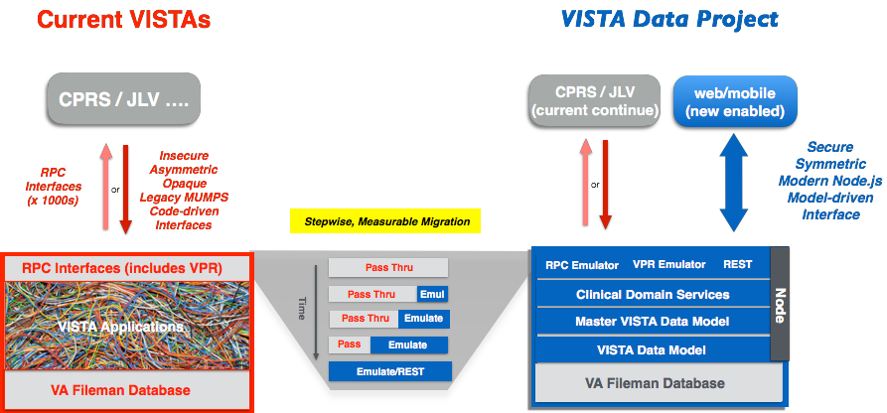

**Strategic Benefits**:

• New, maintainable veteran care server based on mainstream technology

• New web and mobile clients enabled with mainstream technology

• Current clients (CPRS/JLV) supported and enforce VA Care coverage

• May now safely incrementally retire legacy MUMPS VISTA [spaghetti]

• Clinical Domain Services may be implemented over COTS

**VDP Feature:**

**Modern, Secure Model-Driven Interface**

VISTA currently has a variety of bespoke and redundant access, auditing, and authentication mechanisms including FileMan and Remote Procedure Call (RPC) permissions. MVDM introduces (1) comprehensive patient-centric security (2) industry standard attribute-based access control (ABAC) and (3) tiered auditing to VISTA. This new modern data-centric security mechanism allows all data to be safely liberated in modern, mainstream, cloud-native environments where all of the *VISTA* systems are now hosted.

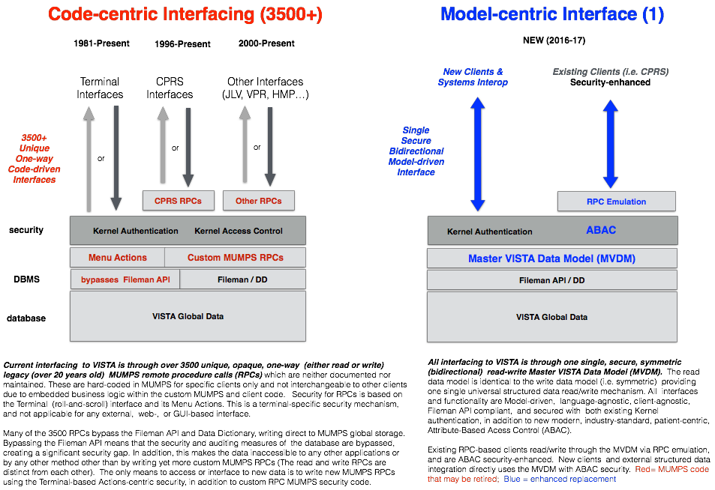

**VDP Feature:**

**Comprehensive Read-Write Data Access**

*VDP* provides 100% coverage of all VISTA data (all 85,000 fields) in web-standard JSON form and – incrementally - is building out a normalized master model for the functionality used by CPRS and other VISTA clients.

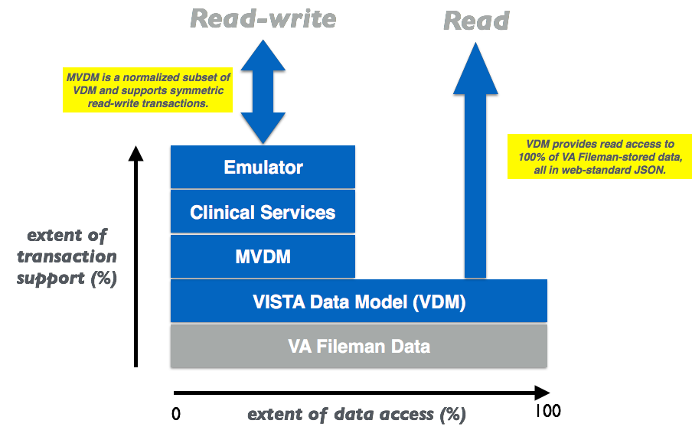

**VDP Feature:**

**Layered Service-Based Data Architecture**

MVDM runs inside VISTA, replacing its spaghetti of M code and interfaces with a modular, model-based, backward-compatible server, making VISTA more maintainable using off-the-shelf tools and technologies.

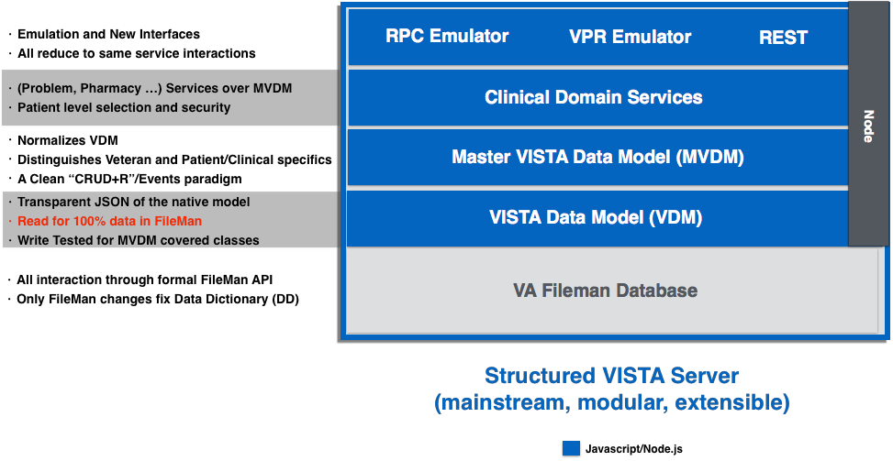

**VDP Deliverables**

The technical deliverables enumerated in PWS that have been completed and delivered.

|  |  |  |
| --- | --- | --- |
| **Deliverable** | **Name** | **Where** |
| 7 | Machine Processable VISTA Data Model (VDM) | Code: VDM in Domain Prototypes |
| 8 | Date-stamped FileMan Data Model  Definitions | Code: otherDeliverables |
| 9 | Approach to “Live VDM” Maintenance of  Current State | Final Report: Live VDM Maintenance |
| 10 | Normalized VISTA Data Model (MVDM) | Code: MVDM in Domain Prototypes |
| 11 | Heuristic Code | Code: Domain Prototypes |
| 12 | Normalization Reports | Final Report: MVDM normalization of  VDM |
| 13 | Website that graphically depicts VDM, MVDM, and other metadata | Code: Website of Project |
| 14 | Report on Exposure of Older Models | Final Report: Exposure of Older Models |
| 15 | Date-stamped Metadata for lab, surgery, TIU notes and other applications in a MVDM compatible format | Code: otherDeliverables |
| 18 | Machine-processable Annotations | Code: otherDeliverables |
| 19 | Software Code | Code: otherDeliverables |
| 23 | End to end Demonstration | *Final Report: End To End Emulation Demonstration – assembled from code deliverables* |
| 25 | Prototype query access to VISTA Data  Against VDM | Code: otherDeliverables |
| 28 | Prototype Patient-centric Data Security | Code: otherDeliverables |
| 33 | Prototype Web-Based Query Interface to  FileMan Data | Code: otherDeliverables |
| 35 | VISTA Application model(s)/Prototype(s) | Code: Domain Prototypes |
| 36 | Meta-model(s)/Prototype(s) (VPR Emulation) | Code: Domain Prototypes - VPR |
| 41 | Security Management Summary Report on  PIKS Annotation | Final Report: Security Management |

Note: per agreed contract amendment, deliverables 23 and 41 replaced 39 and 40

**VDP**

**Exposure of Management of VistA Models Report**

The Vista Data Model (VDM) is generated directly from the internal data model ("Data Dictionary") of VISTA and reflects different styles of coding adopted in VISTA over thirty years and supports data arrangements that are no longer used in the system.

The Master VistA Data Model (MVDM) is a hand curated, hand coded reframing of the native VISTA Data Model (VDM). The other input to MVDM select procedural logic of VISTA, mostly logic that implements remote procedure calls (RPCs) over the VDM.

MVDM is a machine-processable model that reframes VDM and reimplements CPRS RPC behaviors to capture how VISTA currently behaves in a consistent form

**From VDM to MVDM**

1. Establishes common patterns for the same operations and data forms. For example, data is removed and marked as removed in one form in MVDM unlike the variety of forms in VDM. See the "removal" operation in the Problem and Allergy Model.
2. Combines disparate data into single classes where appropriate. For example, in Allergy, the VDM has two objects (Allergy and Allergy Reaction) for noting an Allergy. MVDM combines these two objects into one.
3. Doesn't expose deprecated properties or patterns. For example, MVDM Allergy suppresses the notion of "chart marked". With the advent of CPRS, VA no longer distinguishes an electronic and paper chart.
4. Synthesizes properties to expose implicit values only denoted in comments. For example, observation units in Vitals.
5. Groups related properties into sub objects, making classes more manageable. For example, the VDM Patient class has over 450 properties, largely laid out in one flat list. It makes sense to gather related properties such as an address line and zip code into clearly structured, contained classes.
6. Normalizes properties so that a common property is identified and labeled the same way across relevant objects. For example, in MVDM, a property that references the Patient class is always called "patient". VDM can use "patient_name" or "name". This reflects the desire for global property name scope in MVDM while VDM has, at best, per class name scope for its properties.

In addition, where the VDM of one domain seems to lack a desired property, it is noted in the MVDM. This should promote improvements in the VDM and hence in the MVDM.

For MVDM, RPC logic captures permissible combinations of properties and side effects. For example, in allergies, how an historical allergy differs from an observed allergy. These *behaviors* are embedded in MVDM to ensure that old valid combinations of properties and objects may be created, updated, and deleted.

**VDP**

**MVDM Normalization of VDM**

**Background**: MVDM's normalization of VDM is one of the key reports for project progress measurement and scoping.

The following shows the reduction of redundancy between MVDM and VDM.

**MVDM Class Count VDM Class Count**

Allergy 19 Patient Allergies; Adverse Reaction Reporting 129

Problem 37 Problem-9000011 49

Vital 10 Gmrv_Vital_Measurement-120_5 13

**VDP**

**Live Vista Data Model Maintenance Report**

**Background**

The native Data Model of VISTA (VDM) is a class-centric restatement of VISTA's FileMan Data Dictionary (DD). As such, it is generated from the DD and must change as the DD changes. Keeping VDM up to date means "keeping up with DD changes".

In addition, as the MVDM builds over the VDM, changes to the DD may effect it too.

**Keeping VDM up to date**

Currently when the DD changes, the statically generated VDM must be regenerated. In Year 2 of VDP, we'll move to a *Dynamic VDM* where VDM is rendered on-demand from the DD.

But VDM test code - a large portion of the VISTA Data Project's code is test code - is static and may make assumptions that no longer hold when the DD and then VDM changes. By running test code nightly, we will catch discrepancies nearly as soon as they happen. As many such discrepancies would effect MVDM, the brittleness of the test code is one key utility for keeping MVDM up to date.

**Keeping MVDM up to date**

By its nature the Master VISTA Data Model (MVDM) is manually designed and coded. Two sorts of changes to the DD and then VDM can effect the MVDM:

• additions of new properties or aspects of properties ("is it required", "range of values") that need to be explicitly exposed or addressed in MVDM

• new triggers (cross references, computations) in VDM which means changes to the VDM have unaccounted for side effects

As noted above, the static VDM test code will expose some of these discrepancies. Further discrepancies will be exposed in the MVDM Test code.

In addition, a "VDM Change Report" will be created that will isolate how the VDM has changed. This report will not only aid in interpreting test code failures but will also guide changes not addressed in test code.

**VDP**

**Security Management Summary Report**

Broadly, Security has three aspects:

1. **authentication** (is this Dr Kildare?)

2. **access control** (should Dr Kildare be able to do this?) and

3. **auditing** (what did Dr Kildare do?).

PIKS (Patient-Institution-Knowledge-System) is a model for decomposing the data in a health-care system with a focus on isolating Patient data from other data. **PIKS-based Security** adds another dimension to access control. In addition to the operation being performed (create-read-update-delete) and the object of the operation (the type of data in scope), a PIKS categorization of data adds the organizing principle of health-care, the patient.

**Current RPC Interface to VISTA**

In the current RPC interface to VISTA, a user [1] is authenticated using 2 RPCs with the 2 password access/verify mechanism - effectively authentication looks up a user record. Then [2] access control is applied ("action-based") on each subsequent RPC call - the user's record references a list of permitted RPCs. Finally [3] FileMan can be setup to record an audit trail of the data changed by RPC calls. The "outside world" accesses this setup through the RPC Broker, a TCP server with a proprietary protocol.

This current RPC setup has the following access control and auditing issues:

1. RPC-centric access control is largely "action based": it isn't per patient. For example, it controls whether you can "write a prescription", not whether you can "write a prescription for John".

2. There is a concept of patient - users can be assigned a list of patients. But enforcement relies on client- enforcement. In other words, the client asks the VISTA server, "can my user access patient Fred's

record?". If the answer is no, then the client won't touch Fred but the server doesn't enforce this restriction. In effect, patient access control is purely advisory in the current VISTA scheme.

3. FileMan auditing only works if RPCs call the FileMan APIs (there are two) and don't directly read and write the globals that store FileMan data. **As many bypass the API, there is a large auditing hole**.

Changes happen but FileMan auditing doesn't know.

4. Auditing, where it exists, is on FileMan data but access control is on RPCs ("actions"). In other words, the "paradigms" are inconsistent.

5. While in theory, with data mining, you could partition FileMan audit trails per patient, the system

doesn't do it.

MVDM [1] fits under whatever authentication mechanism VA wants to use going forward, [2] applies patient- centric, data-centric access control ("should Dr Kildare be able to write a Prescription for John") and [3] through its event mechanism provides comprehensive audit trails for all activity.

PIKS delivers the patient-centric part of access control. The dimensions of operation, time or place are not PIKS - "can John write a Prescription at Facility A at midnight?" PIKS adds the patient - "can John write a Prescription at Facility A at midnight for Fred?".

MVDM not only notes the user, the place (facility), the time and operation involved in a procedure - it also knows and notes the patient. The MVDM Management Client displays MVDM audit events which reflect the nuance exposed ...



PIKS involves making *patient* a first class concept along side *user*, *place* (facility), *time* and *operation*. It makes security health-care specific.

With the added dimension of patient, all operations from listing to describing to changing, can be restricted for a user to a particular group of patients.

**VDP End to End Demonstration**

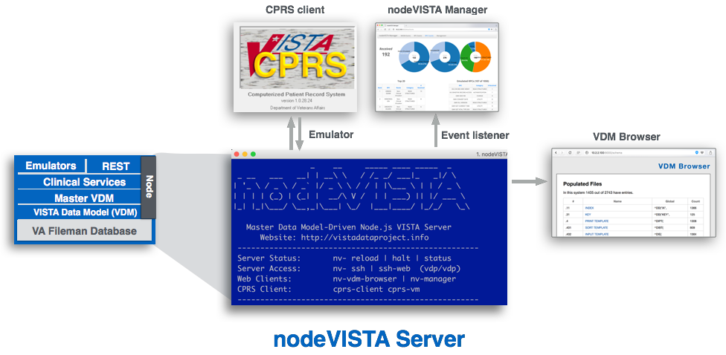

Start CPRS…



Before logging in, notice that the **nodeVISTA Manager RPC Events** tab shows the first RPC traffic coming from CPRS.

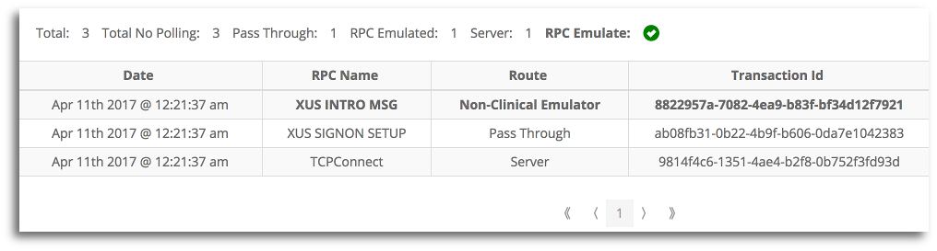

Login into VISTA as **ALEXANDER,ROBERT** using the following credentials:

Access Code: fakedoc1

Verify Code: 1doc!@#$

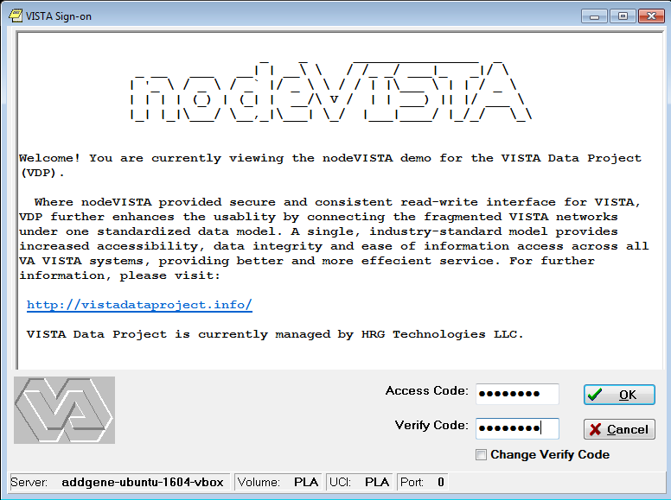

After login, you will be brought to the patient selection dialog…

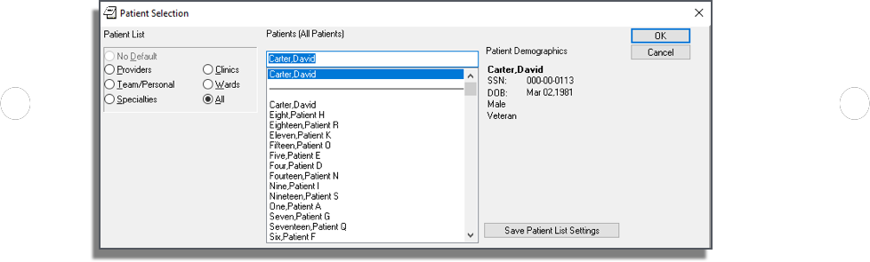

Before choosing patient **Carter,David**, look in the **nodeVISTA Manager** and see just how *chatty* CPRS is. Before any patient is selected, over 80 RPCs have been sent:

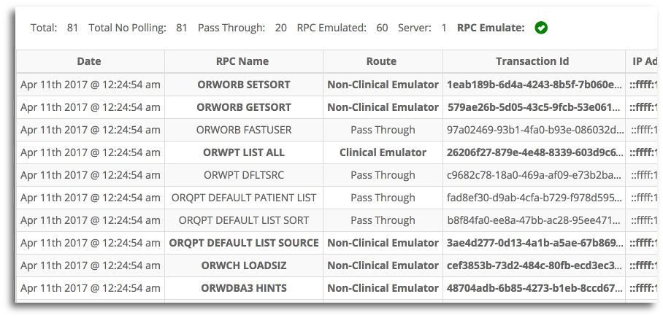

Back at CPRS, select ‘OK’ and you will be brought to the (empty) patient chart

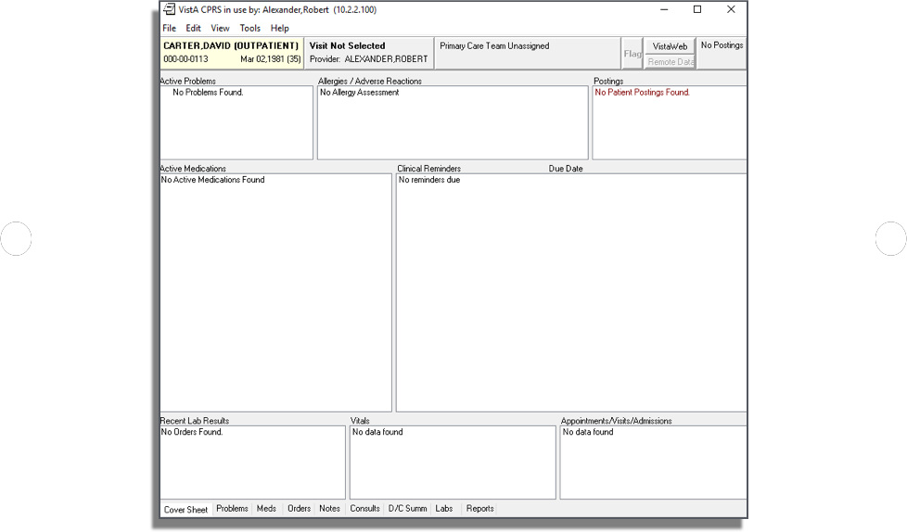

and the **nodeVISTA Manager** shows the extra RPCs invoked - the total is now at 133…

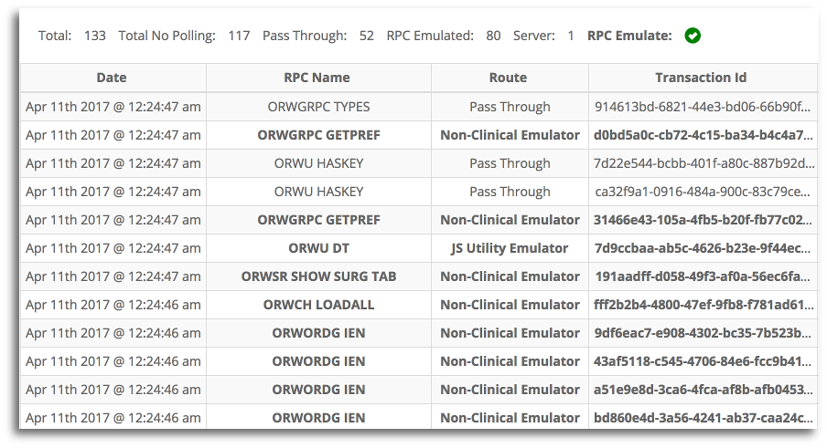

and the **MVDM Events** tab shows MVDM model events for emulated RPCs…

